**ELECTRONIC PROJECT REPORT**

**Topic**: Sine – Cosine Wave Generator.

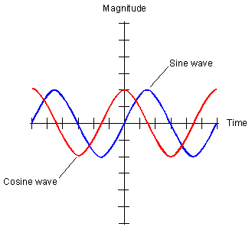

* Rajesh Rathva 201701406
* Harsh Bhatt 201701407
* Dwish Shah 201701408
* Kavit Kheni 201701409

**ASSIGNED BY: PROF. BISWAJIT MISHRA**

**INTRODUCTION**

We know that when the sinusoidal waves superimposed on each other then they remove the effect of counter wave form and make a square wave.

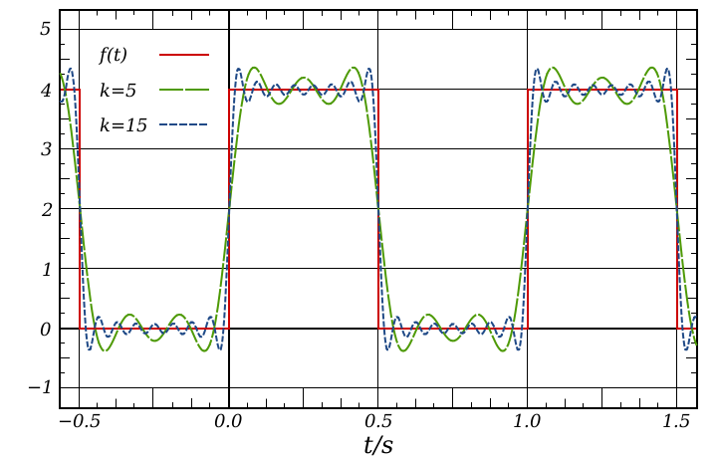

**Logic**

Logic behind generate sine-cosine wave is that if we able to filter square waves which is made by sinusoidal waves then we will get sine wave and then if we differentiate sine wave then we will get cosine wave.

**Diagram**

SquareWave

Filter

Filter

Filter

Differentiator

Apparatus:-

* Operational Amplifiers(LM741)
* Resistors
* Voltage Source(As opm activator)
* Capacitors

**Input**

Square Wave Generator:

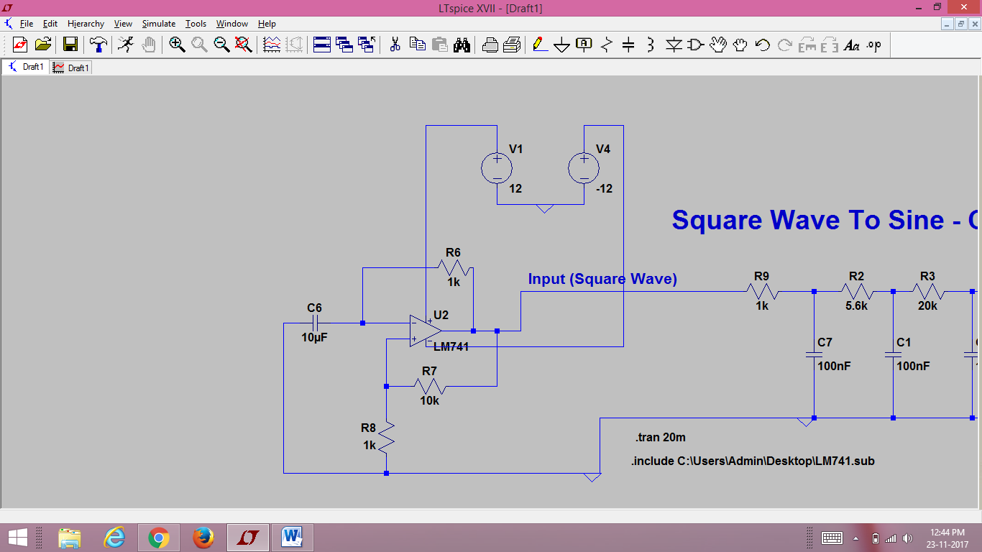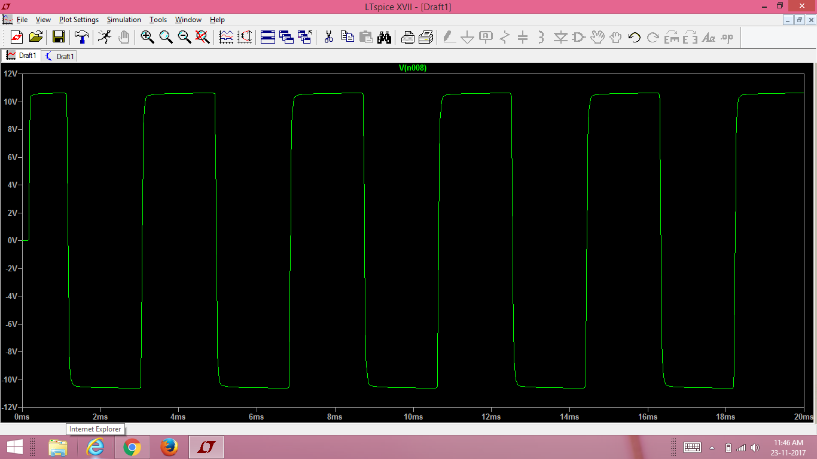

**Output**

First we will get sine wave and then convert it into cosine wave using Differentiator.

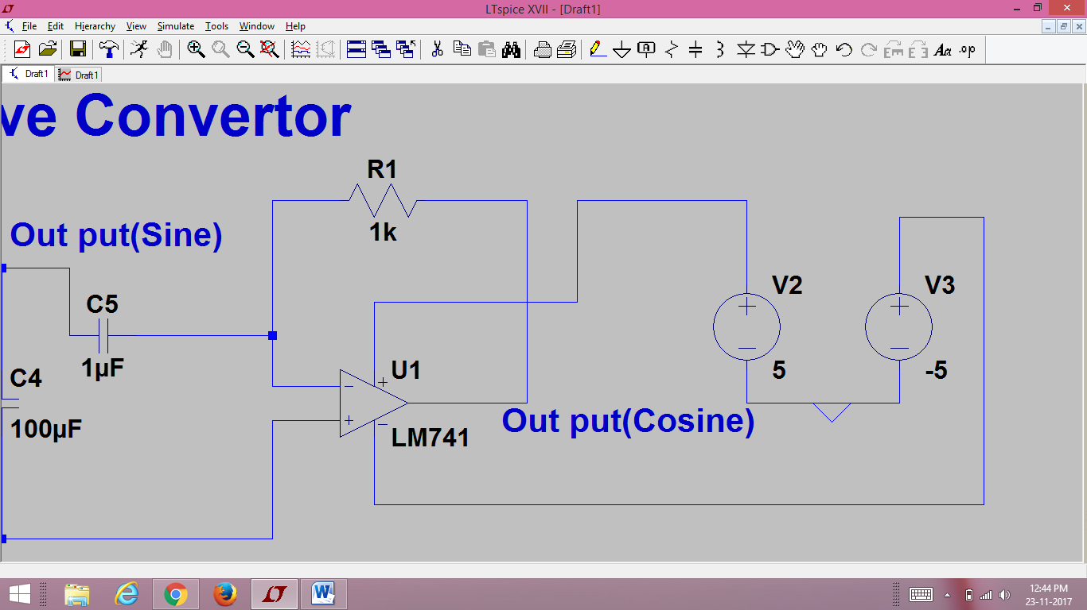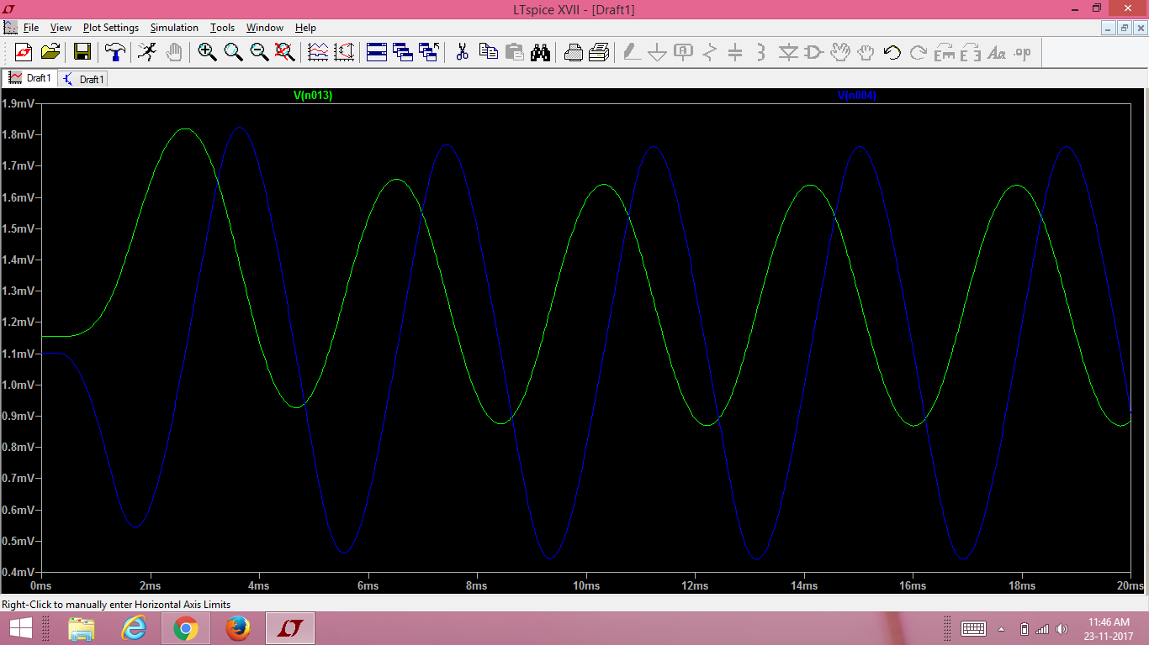

**Whole Process Output**

Output at different nodes.

